**Foundational papers:**

Freyd, J. J. (1983). The mental representation of movement when static stimuli are viewed. Perception & Psychophysics, 33(6), 575–581.

* Subject was shown a static photograph, and later asked if they’d previously seen the photograph. This task was made more difficult if the trial photo was a later stage of the initial photo they had seen. However, the same was not true if the trial photo was of an earlier stage.
* Stimuli were actions: pouring water, jumping off a wall, waves crashing, throwing a ball
* Notably, the movement here was all implied because the stimuli was a static photo. Freyd draws a distinction between semantic and featural information that could have played into people’s predictive power.

Freyd, J. J., & Finke, R. A. (1984). Representational momentum. Journal of Experimental Psychology: Learning, Memory, and Cognition, 10(1), 126–132.

* This study focused on rotational motion, and again found an effect of representational momentum (stronger in clockwise rotation).
* The stimuli here were presented as static photos, and there was even concern about the photos being perceived too closely to a video. Exp 3 drastically slows down the play rate of the photos and retains the RM effect.

Hubbard, Timothy L. "Representational momentum and related displacements in spatial memory: A review of the findings." Psychonomic bulletin & review 12.5 (2005): 822-851.

* Types of displacement- Displacement in the direction of motion (representational momentum), displacement downwards (representational gravity), displacement after contact (representational friction)
* Variables influencing displacement
  + Characteristics of the target- velocity, direction, identity/shape, mass/size, animacy, auditory targets
  + Characteristics of the method- video/image series, predictability of vanishing, retention interval, response measures, error feedback
  + Characteristics of the context- surrounding context, expectations regarding future target motion, attribution of the source of target motion
  + Characteristics of the observer- attention, eye movements, psychopathology

**Variations:**

Medium- pitch (Johnston & Jones 2006), action (Hudson et al., 2016), social position (Kakkar et al., 2019)

Action/method-

* Divided attention- resulted in a weaker representation of the endpoint, participants thought the object had moved further along. (Hayes & Freyd 2002)
* Implied velocity- representational momentum was sensitive to acceleration or deceleration. (Finke et al 1986)

Physical states

* Examined states {melt, shrivel, smolder, deform, burn} and the events were perceived as further along. (Hafri et al 2022)

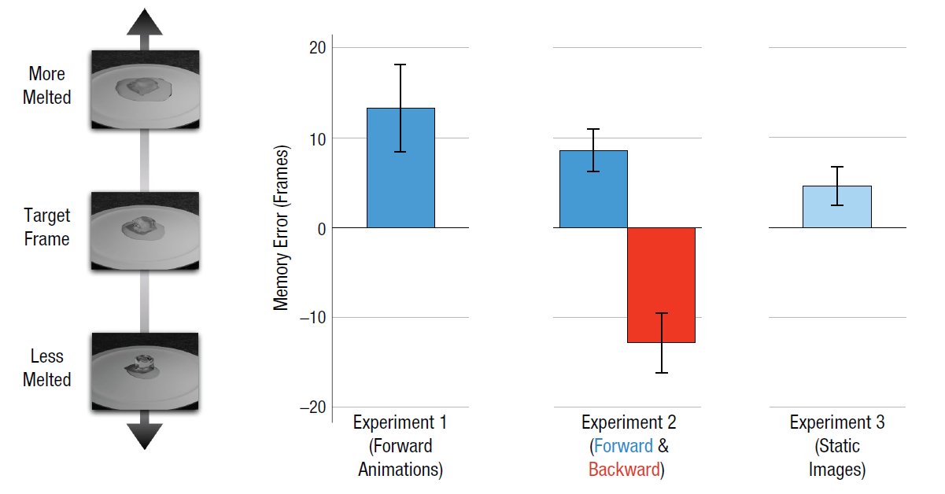

Experiment 1- participants saw a clip of a transformative process and used a slider in an unclipped video to indicate where in the video they thought they stopped

Experiment 2- participants saw a clip of a transformative process either forwards or in reverse (changing the structure of the event) and were once again asked to indicate where they thought the video stopped.

* There is significantly more error for the backwards videos, indicating that familiarity with a given process is helpful

Experiment 3- participants saw a single frame of a video and were asked to indicate which frame they thought they saw

* In general the participants showed forward momentum, indicating a preference for direction

Experiment 4- participants saw a clip of a transformative process and were given a forced choice of two frames they might have ended on (30 frames in either direction)

* There was a significant preference for frames in the forward direction, but not an overwhelming amount.

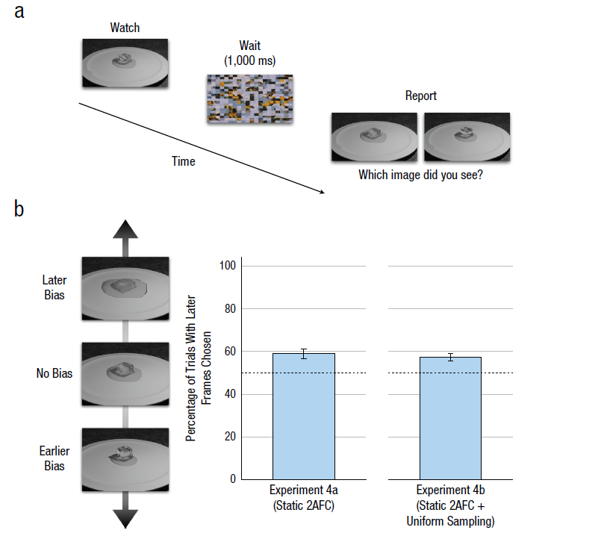

Of note: not been conclusively demonstrated for other continuous properties, such as luminance (Brehaut & Tipper, 1996), hue (Callahan-Flintoft et al., 2020), and emotional expression (Thornton, 2014)

Implications for this project:

* In general, representational momentum work has been done upon a continuous axis- movement, pitch, even melting. But what happens if we look at the very end of motion, near the boundary of some type of event category?
* We want to see if representational momentum is so strong an effect that people will judge a contact event to be the same as an initial baseline no contact event.
* Is representational momentum a product of perception? How is it related to language?
  + Representational momentum affects memory-- is that different than it affecting perception?
  + Language could be a good divide between perception and memory-- “towards the box” would likely not be perceived the same as “to the box”
* Order matters-- momentum is forward moving, a contact event would more definitively set an endpoint than a no contact event.

**Quick references**

Finke, R. A., Freyd, J. J., & Shyi, G. C. (1986). Implied velocity and acceleration induce transformations of visual memory. Journal of Experimental Psychology: General, 115(2), 175–188.

Hayes, A. E., & Freyd, J. J. (2002). Representational momentum when attention is divided. Visual Cognition, 9(1-2), 8-27.

Hafri, A., Boger, T., & Firestone, C. (2022). Melting Ice With Your Mind: Representational Momentum for Physical States. Psychological Science, 33(5), 725–735. https://doi.org/10.1177/09567976211051744